**Department of Computer Science**

|  |  |
| --- | --- |
| **STUDENT NAME** | **Taimoor Manzoor** |
| **STUDENT ID** | **SP20-BSCS-0021** |
| **SECTION** | **AM** |
| **ASSIGNMENT NO.** | **3** |
| **DUE DATE** | **23-10-2020** |
| **SUBMITTED ON** | **22-10-2020** |

**Question 1/Task 1:**

**1. Using the 2D arrays in java, you are required to calculate the grade of 5 students for 5**

**courses. For every student, input the marks for each course from keyboard and display the**

**respective earned grade of the student. (Perform necessary calculations)**

**Hint: Each row of the array represents students, whereas the columns of each row represent**

**the marks of individual courses of that student.**

**Answer:**

In this task we are using 2D array according to the condition of the question. In this task we are using 3 for loop with the nested. The first loop is used for the read the input by the user and second loop is used for the printing the whole input which are taking by the user and the third is used for the sum of the row except 0 columns row and then find the percentage after that using the condition statement and give the grade of the students and all work are doing on the static method and static is used for the data management and then call the static function in the main with the static function name because static function is belong to the class not the object. And we are using 2d array of 5 by 6.

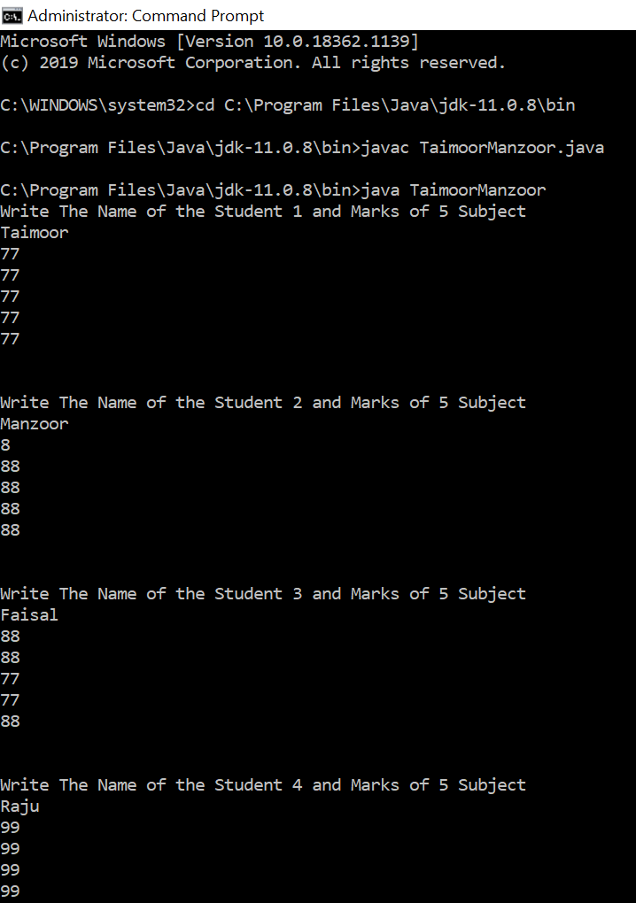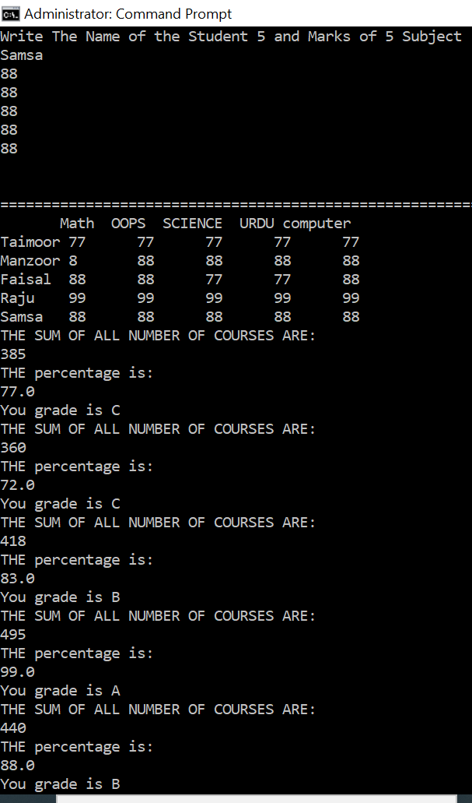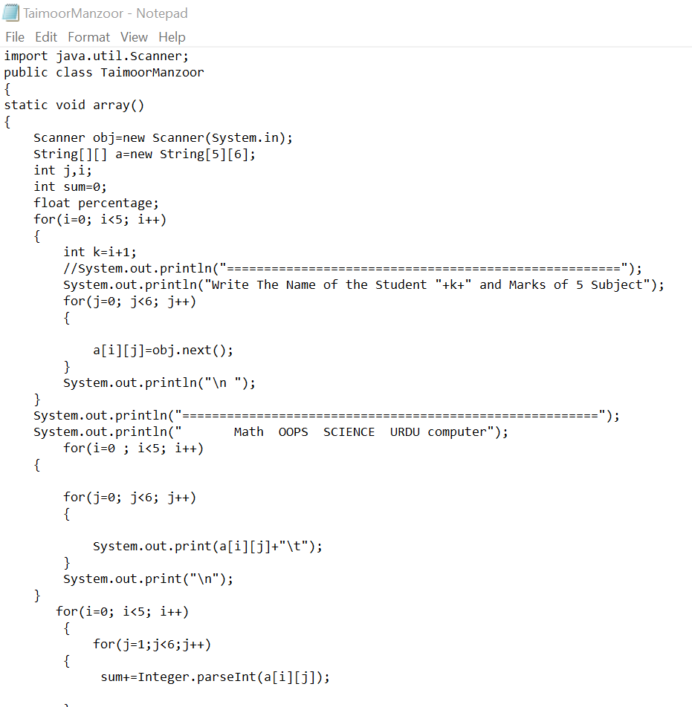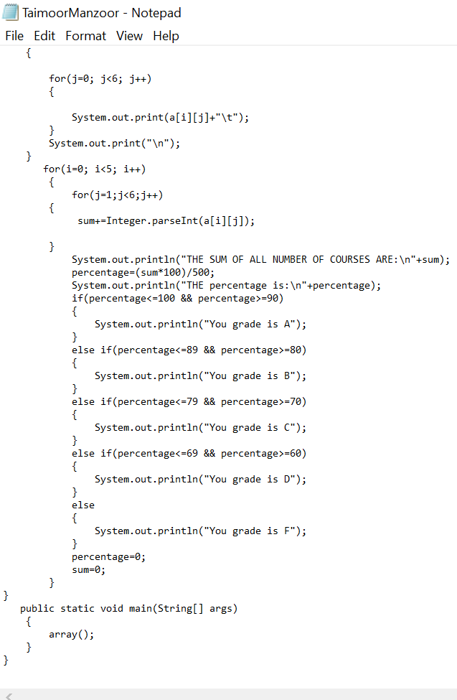

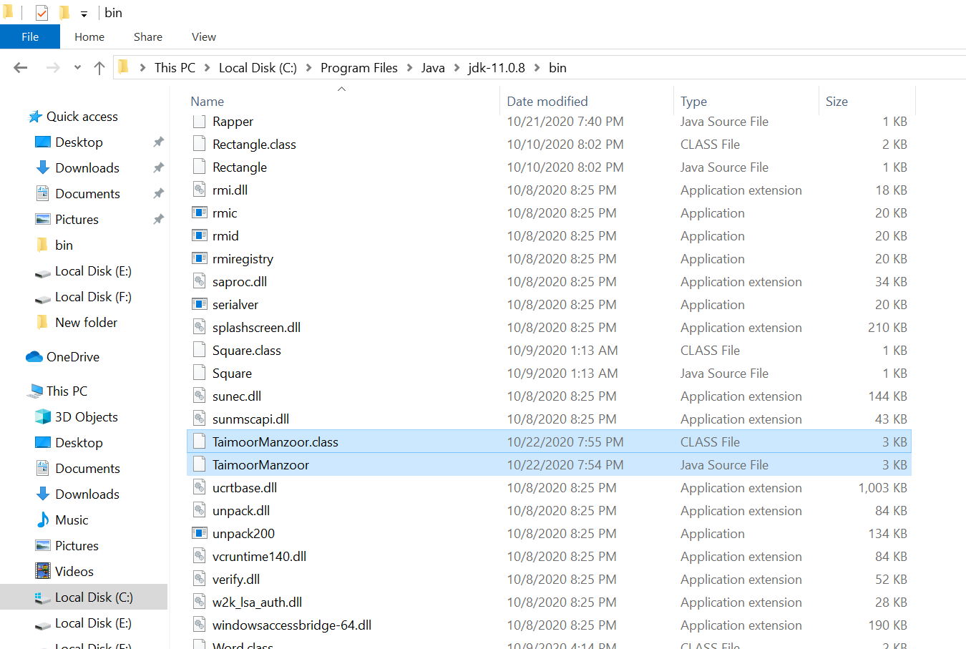

**Question 2/Task 2:**

**2. Using the command line arguments, you are required to pass 5 numbers and print their**

**sum. (Perform typecasting)**

**Hint: Partial code is attached for reference.**

**Answer:**

In this task we are passing the five string and then convert it into integer by using the parsing method and then print the sum of these number.

